## INTERNAL AUDIT MANAGEMENT

**1**

**For create a New Document first you have to generate a new Change Request Token.**

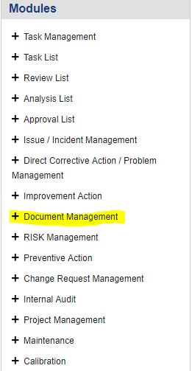

**2**

**1.** Click on the **Document Management** button on the left side of your Screen. A Drop down List will appear.

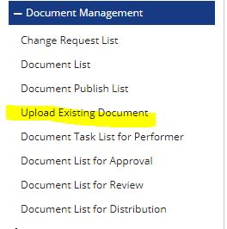

**1.** Click on the **Change Request List** Button & a window will appear soon.

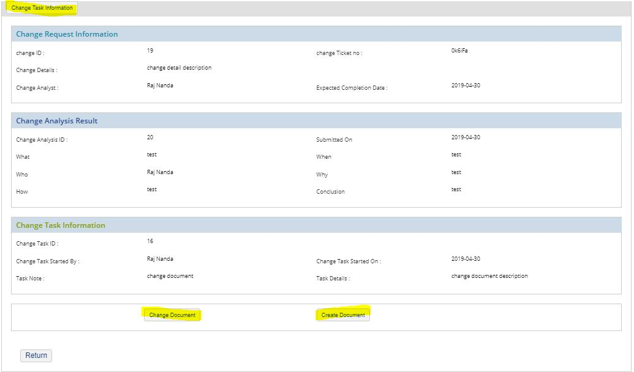

**1.** A form will open named **Change Task Information** Here you fill the marked items to create the issue. Then click on the button below **Chnage Document**. For changing an existing document OR click on the button below **Create Document** .

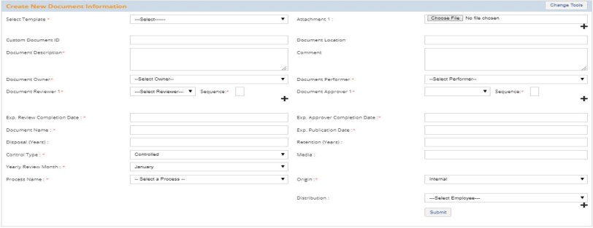

**1.** Click on the **Create Document** Button & a window will appear soon name as **Create New Document Information** .

**2.** Fill Up all Necessary Information and Click on the Submit Button.

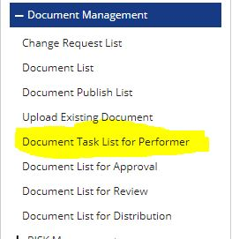

**1.** Click on the **Document Task List for Performer** Button & a window will appear soon.

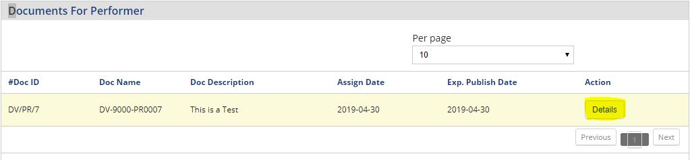

**1.** Here we have to perform a Document. Click on the Details Button.

**1.** Here we can create the issue and **Audit-id-22**. After creating the Audit we have to assign the issue to designated persons to work on the issue.

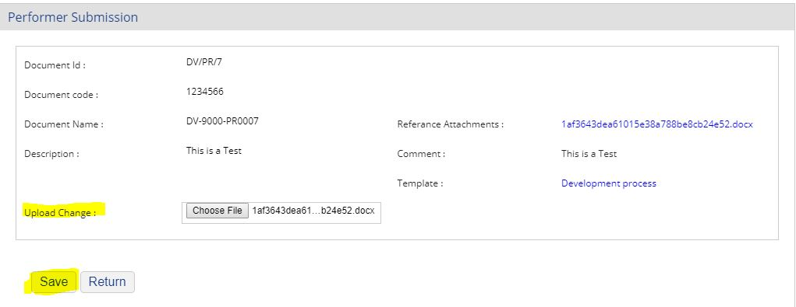

**1.** Here you have to upload the new document & Click on the **Submit** Button**.**

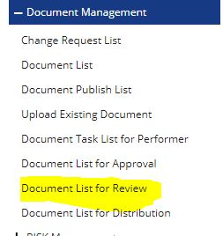

**1.** Click on the **Document List for Review** Button & a window will appear soon.

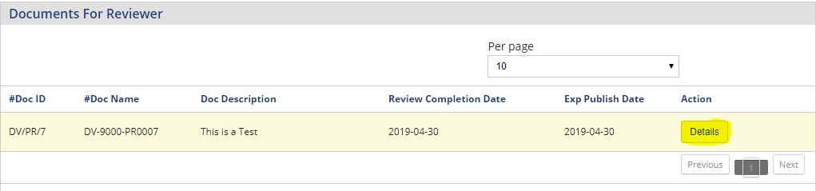

**1.** Here we have to Review a Document. Click on the Details Button.

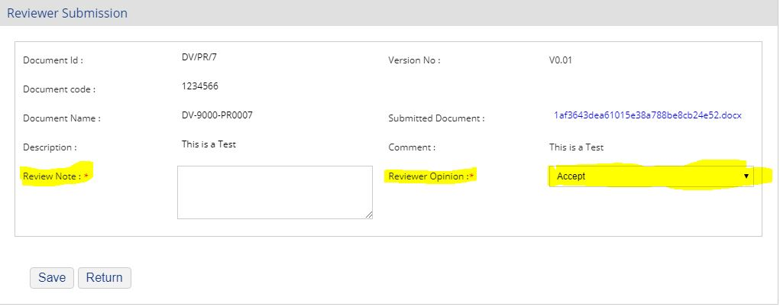

**1.** Here we have to Accept/ Reject Document Change and then click on the Submit Button

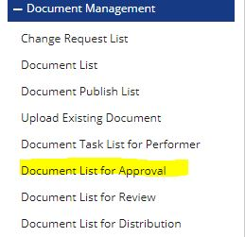

**1.** Click on the **Document List for Review** Button & a window will appear soon.

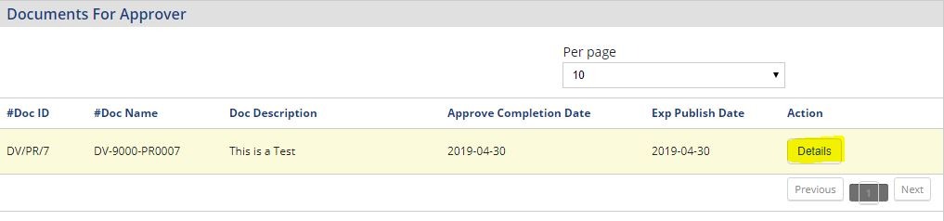

**1.** Here we have to Approve a Document. Click on the Details Button.

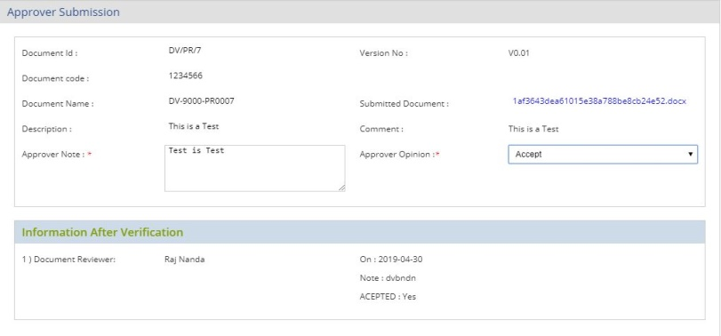

**1.** Here we have to Accept/ Reject Document Change and then click on the Submit Button



**1.** Click on the **Document Publish List** Button & a window will appear soon.

**1.** After that one tab will open click on the publish button that the Document Change Module is Completed.

